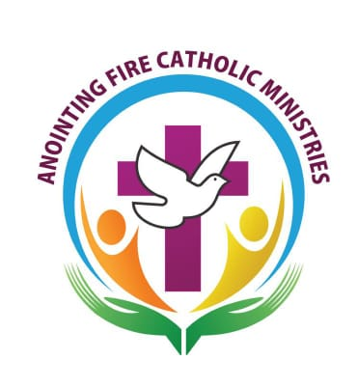
The Day of Atonement and Reparation
Advent – Preparation for Christmas
‘By the rivers of Babylon there we sat and wept when we remembered Zion’
psalm 137:1
Led by: Fr. Bobit Thomas MI
Date: 11th December 2021
Time: 2pm to 5pm
Venue: Our Lady’s Church Carbally Co. Waterford

The day will involve Eucharistic Adoration, a Talk, Confession, Stations of the Cross, The Holy Eucharist (holy mass for atonement)
All are welcome

