Nos. | Parish | Christmas Liturgical Schedule 2023
1 | Waterford: Sacred Heart | Carols by Candlelight  The Annual Parish Carol Service takes place on  Monday, 18th December 2023, beginning at 7:30pm.  This is always a very special part of the preparation for  Christmas - All are welcome.  Advent Penance Service  The Advent Penance Service will be celebrated on  Thursday, 21st December 2023 at 7.00pm.  - Saturday 23rd December – 10:00am and 6:30pm  - Christmas Eve:  8:30am; 10:00am and 11:30am (Confessions after all morning Masses)  7:30pm and Midnight  - Christmas Day:  8:30am; 10:00am and 11:30am  - Tuesday 26th December - 10:00am
2. | Carrick-on-Suir | 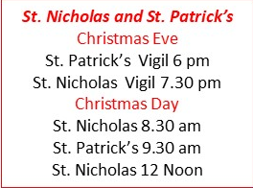
3. | Ballyneale | 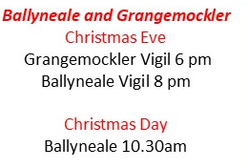
4 | Waterford: St. Joseph & Benildus – details from their website | 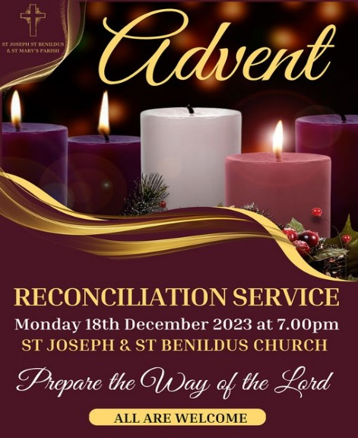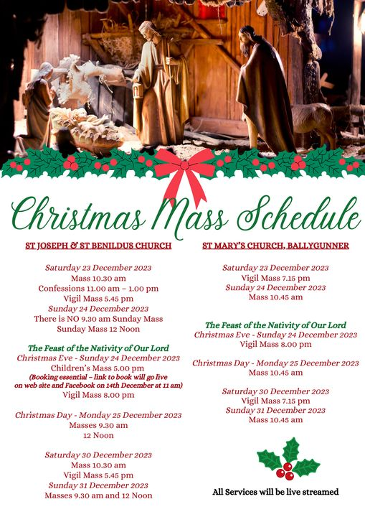
5 | Waterford: St. Saviours | Mass times for Christmas:  Christmas Eve: 6.30pm. (confession between 5pm-6pm.), Christmas Day Mass: 8.30am and 11am.
6 | Ardfinnan | Saturday 23rd / Sunday 24th December  4th Sunday in Advent – Masses As Usual Sunday Schedule  (Please note this is NOT the Christmas Mass)  Saturday 23rd :  6.30pm Ardfinnan  10.30am Grange / 11am Nire /  12pm Ballybacon.  CHRISTMAS MASSES  CHRISTMAS EVE VIGIL MASSES: SUNDAY 24TH DECEMBER  5pm - Newcastle  7pm Touraneena  7pm - Ardfinnan (Broadcast on www.churchservices.tv/ardfinnan )  CHRISTMAS DAY - MONDAY 25TH DECEMBER  9am- Fourmilewater  10.30- Grange  11am Nire  12pm – Ballybacon  Tuesday 26th – Wednesday 27th – Thursday 28th No MASSES  Friday 29th  9.30am Mass – Ardfinnan  Saturday 30th / Sunday 31st As usual Sunday Times  Monday 1st Jan – No Mass.
7 | Newcastle | Saturday 23rd / Sunday 24th December  4th Sunday in Advent – Masses As Usual Sunday Schedule  (Please note this is NOT the Christmas Mass)  Saturday 23rd : 5pm Newcastle  Sunday 24th: 9am Fourmilewater  CHRISTMAS MASSES  CHRISTMAS EVE VIGIL MASSES: SUNDAY 24TH DECEMBER  5pm - Newcastle  CHRISTMAS DAY - MONDAY 25TH DECEMBER  9am- Fourmilewater  Tuesday 26th – Wednesday 27th – Thursday 28th No MASSES  Saturday 30th / Sunday 31st As usual Sunday Times  Monday 1st Jan – No Mass.  Saturday 30th / Sunday 31st As usual Sunday Times  Monday 1st Jan – No Mass.
9 | Clonmel: St. Olivers | Advent retreat Saturday 16th 11-1500  Christmas Eve Vigil 1930  Christmas day 900 and 1200
10 | Cahir | St. Mary’s Cahir - Christmas Services 2023  Saturday 16th December 2023  Christmas unwrapped – a day of events to celebrate  the REAL Christmas  Live Crib – 4:00 to 8:00pm approx - Parochial House  Servant Sisters of the Home of the Mother  Followed by Tea/Coffee/Hot Chocolate  Confessions & Adoration - 4:00pm – 5:00pm & After Mass  Monday 18th December 2023  Mass @ 10:30am  Tuesday 19th December 2023  Mass @ 10:30am  Wednesday 20th December 2023  Mass @ 10:30am  Thursday 21st December 2023  Mass @ 10:30am / Confessions 11:00am – 11:30am  Friday 22nd December - Mass 10:30am  & Adoration with Confessions  Saturday 23rd December 2023  Mass @ 10:30am / Confessions 11:00am – 11:30am  Saturday 23rd December 2023  Mass @ 6:00pm- Vigil Mass of 4th Sunday of Advent  Sunday 24th December 2023  Morning Mass @ 10:00am  (9:00am & 11:00am Masses cancelled)  Sunday 24th December 2023– Christmas Eve Masses  Mass @ 6:00pm – First Mass of Christmas with  Comhaltas Ceoltoiri na Cathrach playing  Mass @ 9:00pm Vigil Mass of Christmas Day with  members of Cahir to Sing  Monday 25th December – Christmas Day  Mass @ 9:00am & 11:00am  Tuesday 26th December Mass @ 10:30am  Wednesday 27th / Thursday 28th  & Friday 29th 2023 Mass @ 11:00am  Saturday 30th December 2023  Vigil Mass of Sunday – @ 6:00pm  Sunday 31st December 2023  Mass @ 9:00am & 11:00am  Monday 1st January 2024 – New Year’s Day  Mass @ 10:30am  Masses return to normal times  Feast of the Epiphany –  Thursday 5th January Vigil Mass @ 7:00pm  Friday 6th January – Mass @ 10:30am
11 | Abbeyside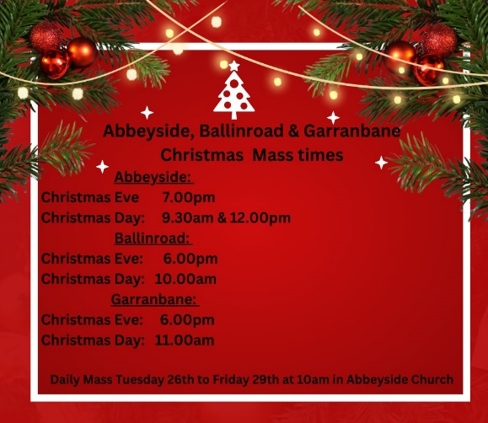 | Abbeyside:  Christmas Eve 7.00pm  Christmas Day 9.30am & 12.00pm  Ballinroad:  Christmas Eve: 6.00pm  Christmas Day: 10.00am  Garranbane:  Christmas Eve: 6.00pm  Christmas Day: 11.00am  Daily Mass Tuesday 26th to Friday 29th @10.00am in Abbeyside Church.  To View any Mass at St Augustine’s Church, Abbeyside go to https://abgparish.ie/live/ or YouTube: ABG Parish
12 | Ardmore | Parish of Ardmore & Grange  Christmas Mass Times  ARDMORE CHURCH  December 24th Christmas Eve: 7.30 p.m.  [Sunday]  December 25th Christmas Day: 11.30 a.m.  [Monday]  GRANGE CHURCH  December 25th Christmas Day: 10.00 a.m.  [Monday]  NOTE:  There will be NO weekday Mass until Monday January 1st 2024
 | Cappoquinn | Cappoquin Parish Christmas Ceremonies from their Facebook page  Confessions  Saturday 23rd Cappoquin 12-1pm  Masses,  Sat, 23rd Vigil Mass Affane 7pm  Sunday 24th Modeligo 10am  Cappoquin 11.30am  Christmas Eve Vigil Masses  7pm Affane  9pm Cappoquin  Carols will begin at 8.30pm  Christmas Day Masses Dec, 25th  10am Modeligo  11.30am Cappoquin  Masses Tues, 26th - Fri, 29th 10am.  Masses in Cappoquin can be listened to on Radio Frequency  FM 98.5.
13 | Powerstown | POWERSTOWN CHURCH  Saturday 23rd December:  Confessions 11:00am - 11:30am  Mass 6:15pm. Confessions afterwards  Sunday 24th Dec. Mass 10.45am  Christmas Eve Mass and Blessing of Crib at 6:15pm  Christmas Day: Monday 25th December  Mass at 10:45am.  LISRONAGH CHURCH  Saturday 23rd December  Confessions 12 Noon - 12:30pm  Sunday 24th Dec. Mass 12 Noon  Christmas Eve: Carol singing begins at 7:40  Christmas Eve Mass and Blessing of Crib at 8:00p.m.  Christmas Day-Monday - 25th Dec. Mass at 12 Noon  Wed. 20st December: Clonmel Area Penitential Service at the Friary Church 7:30pm. (provisionally
14 | Waterford: Holy Family | Christmas Eve, 6.15 p.m. Mass  Christmas Day, 9.30 a.m. & 11 a.m.
15 | Waterford: Ballybricken | Parish office line not ringing
16 | Waterford: St. Johns | Christmas Carol Service, 7.30 p.m. in St. John’s Church, Parnell Street  24th December, Christmas Vigil, 9 p.m.,  25th December, Mass 9 a.m., & 12.00 noon
17 | Clonmel: St. Mary’s | Christmas Eve  (Sunday)  10:30am Mass  12:00 noon Mass  5:30pm Childrens Mass  8:00pm Mass (Carols at 7:30pm)  Christmas Day  (Monday)  9:00am Mass at Marlfield Church  10:30am Mass  12:00 noon Mass  St. Stephen’s Day  (Tuesday)  NO MASSES TODAY
18. | Waterford: St. Pauls | PARISHES OF ST. PAUL’S CHRISTMAS ARRANGEMENTS 2023  DECEMBER 16th & 17th RECONCILIATION WEEKEND:  Opportunity for Individual Confession & Absolution immediately after 6.00P.M., 8.30A.M., & 11.30A.M. Masses.  DECEMBER 23RD – CONFESSIONS 11.00A.M. to 1.00P.M in St. Paul’s  DECEMBER 24TH: CHRISTMAS CAROLS  7.30P.M. In St. Paul’s  FIRST MASS OF CHRISTMAS  8.00P.M. In St. Paul’s  CHRISTMAS DAY MASSES  8.30A.M. In St. Paul’s  11.30A.M. In St. Paul’s  DECEMBER 26TH  10.30 A.M. Mass in St. Paul’s  DECEMBER 27TH to 29TH INCLUSIVE  Mass in St. Paul’s at 10.30A.M each morning except Thursday.  Normal Schedule for Saturday.  FEAST OF THE EPIPHANY  SATURDAY 6th of January 2024  Mass Times  11.30A.M. St. Paul’s  6.00P.M. St. Paul’s
19. | Waterford: Butlerstown | PARISH - BUTLERSTOWN  CHRISTMAS ARRANGEMENTS 2023  DECEMBER 16th & 17th RECONCILIATION WEEKEND:  Opportunity for Individual Confession & Absolution immediately after 10.00A.M. (Butlerstown)  DECEMBER 24TH: CHRISTMAS CAROLS  6.30P.M. In Butlerstown  FIRST MASS OF CHRISTMAS  7.00P.M. In Butlerstown  CHRISTMAS DAY MASSES  10.00A.M. In Butlerstown  DECEMBER 26TH  12.00 Noon Mass in Butlerstown  DECEMBER 27TH to 29TH INCLUSIVE  Normal Schedule for Saturday.  No Mass on Friday in Butlerstown  FEAST OF THE EPIPHANY  SATURDAY 6th of January 2024  Mass Times  10.00A.M. Butlerstown
20. | Waterford: Cathedral | Cathedral of the Most Holy Trinity Within  23rd December – Vigil Mass of the 4th Sunday of Advent  6.15pm  24th December – Mass of the 4th Sunday of Advent  8.30am  12 Noon  Christmas Eve – Vigil Mas of the Nativity of the Lord  7.30pm  25th December – Christmas Day – Mass of the Nativity of the Lord  8.30am  12 Noon  Confessions  18th - 22nd December  11am  23rd December  11am - 1pm  2pm - 5.30pm  24th December  9.30am - 10.30am  After Noon Mass
21. | Tramore | Tramore  December 23rd  7.30pm - Vigil  December 24th  8.30am & 10.30am  7.30pm - First Mass of Christmas  December 25th  8.30am & 10.30am & 12 Noon  Carbally  December 24th  7.30pm First Mass of Christmas  December 25th  11.00am
22. | Dunhill & Fenor | December 16th /17th - Dunhill/Fenor  Sacrament of Reconciliation after all Masses.  Fenor  December 23rd  6.00pm - Vigil  December 25th  10.00am  Dunhill  December 24th  9.30am  7.30pm - First Mass of Christmas
23. | Dungarvan: St. Mary’s | Schedule of Masses from Dec. 18th, 2023, until Jan. 8th, 2024. Schedule of Masses from Dec. 18th , 2023, until Jan. 8th , 2024. Monday, Dec. 18th - Friday, Dec. 22nd : 9.30am Mass each day. If there is a funeral, only one Mass at 11a.m. - the Funeral Mass. Saturday, Dec. 23rd : No Morning Mass on Saturdays. Saturday, Dec. 23rd: 7.30pm Vigil Mass of the 4th Sunday of Advent. Sunday, Dec. 24th: 10am & 12noon Masses. Sunday, Dec. 24th: Christmas Eve, 9pm Mass. Monday, Dec. 25th: Christmas Day: 10am and 12noon. Tuesday, Dec. 26th – Friday, Dec. 29th: 11am Mass each day. Saturday, Dec. 30th : 7.30pm Vigil Mass. The Holy Family. Sunday, Dec. 31st : Feast of The Holy Family: 10am & 12noon Masses. 2024. Monday, Jan. 1st - Friday, Jan. 5th : 11am Mass each day. Friday, Jan. 5th : Eve of the Epiphany: 6.15pm Vigil Mass in the Friary. No Vigil Mass in St. Mary’s. Saturday, Jan. 6th : The Epiphany of the Lord: 11am Mass only.  Confessions for Christmas in St. Mary’s Parish Church. Mon - Fri, Dec. 18th – 22nd : after 9.30am Mass. Monday, Dec. 18th : Penance Service, St. Mary’s, 7.30pm Saturday, Dec. 23rd : 12 to 1pm and 2 – 3pm. Sunday, Dec. 24th : after Masses and 3 – 4pm.
24. | Kilgobinet | St. Patrick’s Church, Kilbrien: Saturday, Dec. 23rd : 7.30pm Vigil Mass. Sunday, Dec. 24th : No Christmas Eve Mass. Monday, Dec. 25th : 10am Christmas Day Mass. Saturday, Dec. 30th : 7.30pm Vigil Mass, Colligan Church. Masses for the Feast of the Epiphany, Jan. 6th in St. Mary’s and the Friary. Saturday, Jan. 6th : 7.30pm Vigil Mass. The Baptism of the Lord St. Anne’s Church, Colligan: Saturday, Dec. 23rd : 7.30pm Vigil Mass, Kilbrien Church. Sunday, Dec. 24th : 8pm Christmas Eve Mass. Monday, Dec. 25th : 12noon Christmas Day Mass. Saturday, Dec. 30th : 7.30pm Vigil Mass. The Holy Family Masses for the Feast of the Epiphany, Jan. 6th in St. Mary’s and the Friary. St. Gobnait’s Church, Kilgobinet: Sunday, Dec. 24th : 11.30am Mass. Sunday, Dec. 24th : No Christmas Eve Mass. Monday, Dec. 25th : 11.30am Christmas Day Mass. Sunday, Dec. 31st : Feast of the Holy Family, 11.30am Mass. Masses for the Feast of the Epiphany, Jan. 6th in St. Mary’s and the Friary. Sunday, Jan. 7th : The Baptism of the Lord, 11.30am Mass.
25. | Ring | Séipéal San Nioclás, An Rinn: Saturday, Dec. 23rd : 6pm Vigil Mass. Sunday, Dec. 24th : 9pm Christmas Eve Mass. Monday, Dec. 25th : No Christmas Day Mass. Saturday, Dec. 30th : 6pm Vigil Mass of the Feast of the Holy Family  Church of the Nativity of the Blessed Virgin Mary, Sean Phobal: Sunday, Dec. 24th : 10.30am Mass. Sunday, Dec. 24th : No Christmas Eve Mass. Monday, Dec. 25th : 10.30am Christmas Day Mass. Sunday, Dec. 31st : 10.30am Mass. Feast of the Holy Family.
26. | Clonmel: SS. Peter & Pauls | Church of the resurrection,  Christmas Eve mass at 7:00pm  Christmas Day mass 10:00am  Confession  Christmas Eve at 12:00 - 1:00pm  Penitential service for the town in the abbey house of prayer, Tuesday, 19th December, at 7:30pm.  Ss. Peter and Paul  Christmas Eve pageant and mass at 9:00pm Christmas Day masses, 9:30am 11:00am 12:30pm.  Confession Christmas Eve at 12:00 - 1:00pm
27. | Carrick-beg | 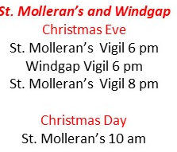
28 | Clashmore | Parish of Clashmore & Piltown  Christmas Mass Times  PILTOWN CHURCH  December 24th Christmas Eve 6.00 p.m.  [Sunday]  CLASHMORE CHURCH  December 25th Christmas Day: 10.00 a.m.  [Monday]
30. & 31 | Cappoquin & Modeligo
32. | Kilsheelan | Christmas Masses 2023  St. Mary's Church, Kilsheelan  Saturday 23rd December - Mass at 6pm  Sunday 24th December Christmas Eve - Mass at 6pm  Monday 25th December Christmas Day - Mass at 11.30am  St. John the Baptist Church, Kilcash  Sunday 24th December - Mass at 10am  Sunday 24th December Christmas Eve - Mass at 8pm  Monday 25th December Christmas Day - Mass at 10am  The Christmas penitential service will take place on next Saturday 9th of December in Kilsheelan during the vigil Mass and on Sunday 10th of December in Kilcash during the 10am Mass.
 | Touraneena | Saturday 23rd / Sunday 24th December  4th Sunday in Advent – Masses As Usual Sunday Schedule  (Please note this is NOT the Christmas Mass)  Saturday 23rd : 7pm Touraneena  Sunday 24th:  11am Nire  CHRISTMAS MASSES  CHRISTMAS EVE VIGIL MASSES: SUNDAY 24TH DECEMBER  7pm Touraneena  CHRISTMAS DAY - MONDAY 25TH DECEMBER  11am Nire  Tuesday 26th – Wednesday 27th – Thursday 28th No MASSES  Saturday 30th / Sunday 31st As usual Sunday Times  Monday 1st Jan – No Mass.
 | Killea | Christmas Mass Schedule  Saturday23: Advent 4  6.30pm St Nicholas’, Faithlegg Vigil  Sunday 24: Morning – Advent 4  10.00am Holy Cross, Killea  11.30am St John the Baptist, Crooke  Sunday 24: Evening – Christmas Eve  6.00pm St John the Baptist, Crooke  8.00pm Holy Cross, Killea  Monday 25: Christmas Day  8.30am Holy Cross, Killea  10.00am St Nicholas’, Faithlegg  11.30am St John the Baptist, Crooke  Confessions for Christmas  Saturday, December 23, from 9.30am to 10.30am in Holy Cross Church, Killea.
 | Newtown | 5.30 Christmas Eve Saleen  7pm Kilmacthomas Chirstmas eve  10.00 am Kill Christmas day  11.30 Newtown Christmas day

